**Adar Alfandari EPK**

[**LISTEN HERE**](http://linktr.ee/adaralfa) **//** [**PRESS PICTURES**](https://drive.google.com/drive/folders/1-_ytQKF6OuhC9rcTGqC6oDysfTCEDgPD?usp=sharing) **//** [**LIVE EXAMPLES**](http://linktr.ee/AdarLive)

**FFO: The Black Keys, Royal Blood, Father John Misty**

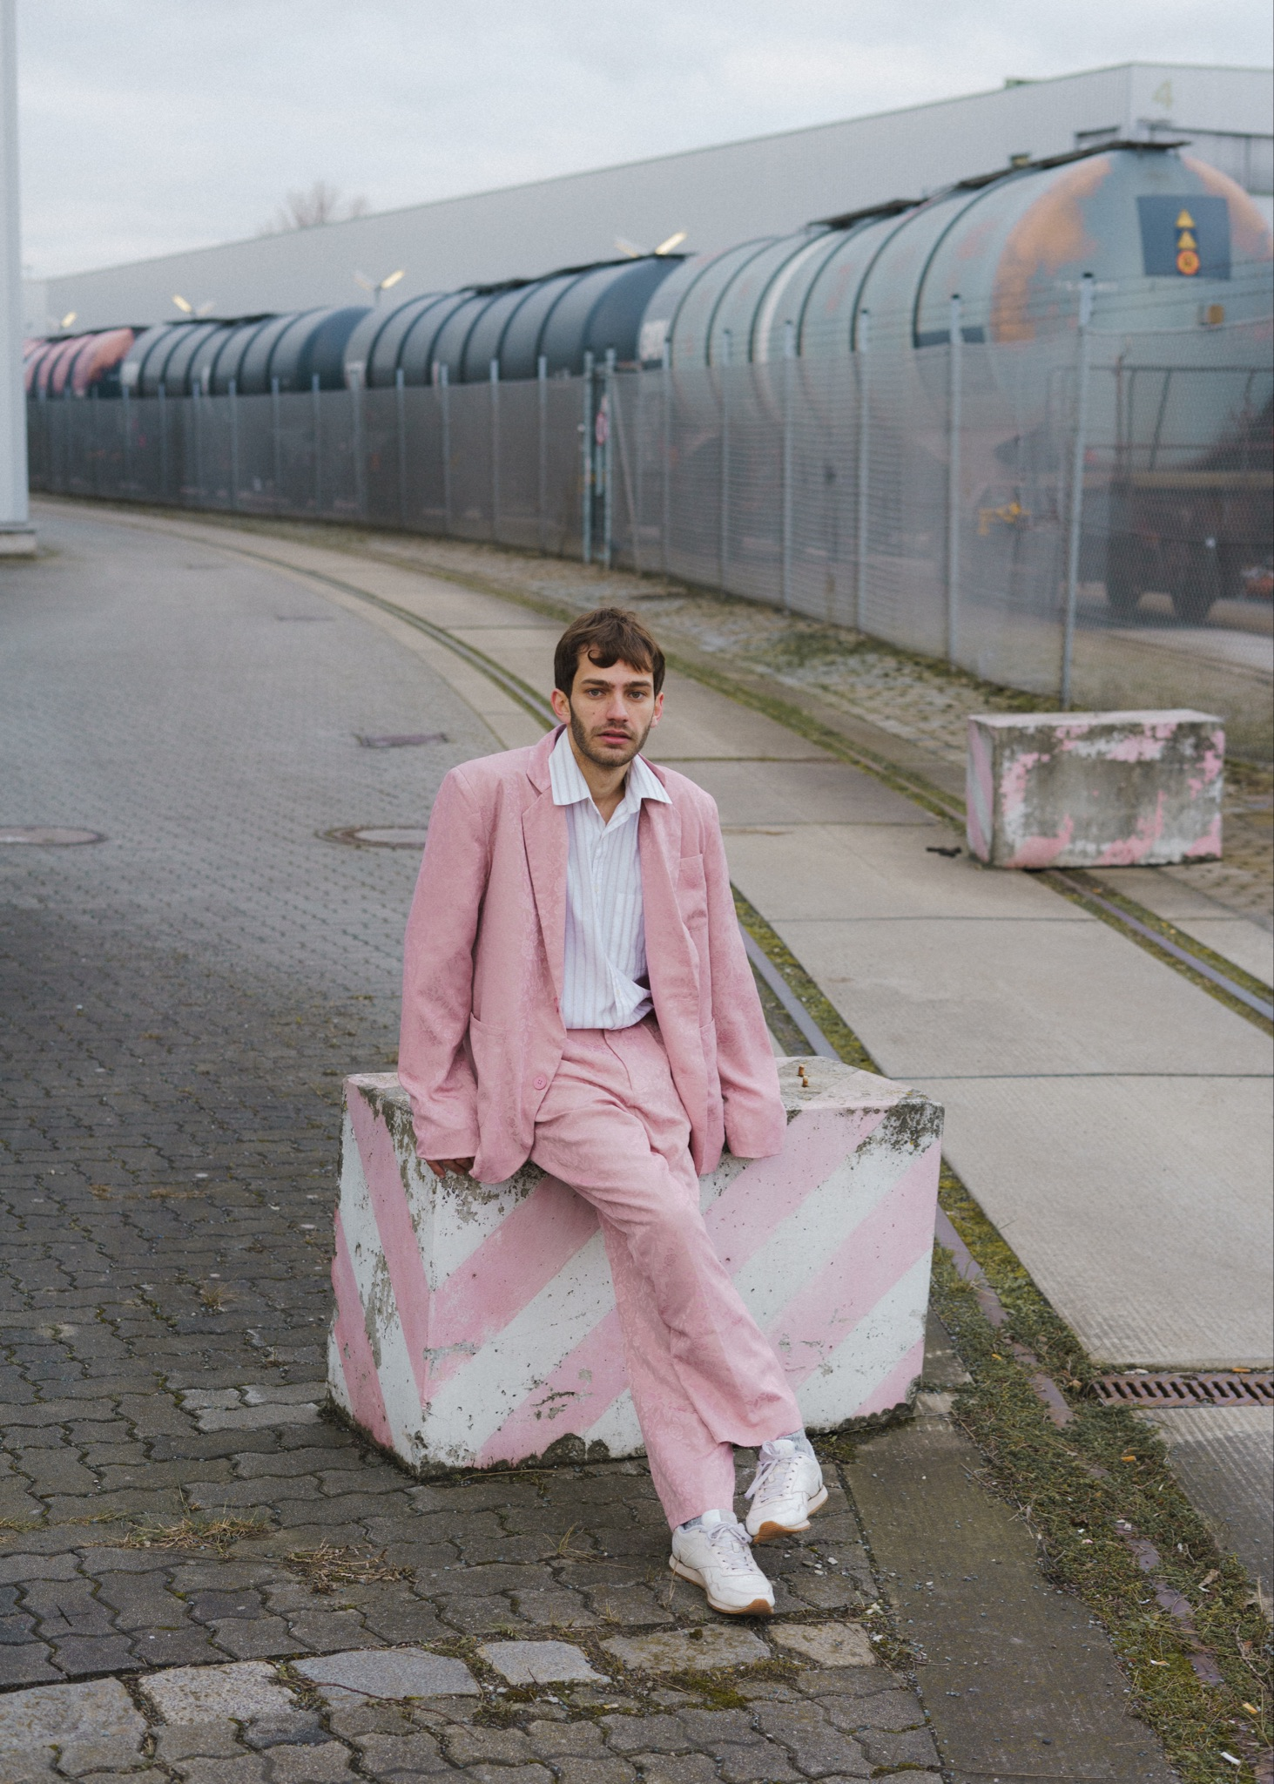

**Israeli singer-songwriter Adar Alfandari, a fresh breeze in the busy music scene, infused with energy, saucy guitar licks, catchy melodies and of course a pink suit.**

Following the release of his debut album “Gold Dust” in August 2021, and 3 European tours in the following years, Adar is finally about to release his 2nd album ‘Amateur Architect’ which was written and recorded during his first tour and his journey to find a home, which eventually lead him to Berlin. That new album captures his travels with colourful and diverse inspirations, guest artists and unique instrumentalists he recorded along the way. The album is set to be released this September with Waldinsel Records (DE) following a summer tour with his exciting new trio!

27-year-old Adar Alfandari has been a musician for as long as he can remember and is a founding member of the Hebrew alt rock band, ‘Dor Hamabul’. The band experienced success on Season 5 of The Voice Israel and have toured all over the country.

Adar began working on his solo project while studying Ableton at college and soon became hooked on producing his own sound. As his flair for production developed, Adar joined up with producer Idan Katz for his debut album ‘Gold Dust’. He is producing his second album by himself, with the assistance of Austin Rossiter, getting more involved in every step of the process and experimenting with endless new ideas.

Adar’s music is often described as versatile, expressive and full of energy, especially in a live setting, both because of the colourful song’s repertoire that varies from gentle acoustic folk tunes and his own strain of hazy alternative rock songs, and also because of his unique way of projecting his art which is somewhat playful and chaotic. He moves a lot on stage, plays out of the box guitar lines, and usually gets captivated and somewhat spellbound by the moment. And all of that taken a notch further (and heavier) with his trio.

Along his 2023 tour Adar met ‘Waldinsel Records’ from Buchholz (Germany) and joined their family. With whom he is currently releasing his upcoming 2nd album, and making the much anticipated band tour this summer, with 13 shows around Germany and Israel!

The upcoming album ‘Amateur Architect’, is going to include 18 tracks (!), with some singles from it already released. The album shows Adar’s musical range, with songs which vary from acoustic folk to Alternative rock and jazz.

"Adar is proving himself to be an artist to watch, with immense potential, and a distinctive and charismatic style that he seemingly inhabits with masterful ease"

**FAMEmagazine**

*“Jessica* offers us a laid-back take on world taboos with the poignant and melting voice of Adar Alfandari. You won't be able to resist the charm of *Jessica's funny and passionate narrative,* an opus worthy of the talented artist”

**IGGY Magazine**

---------------------------------------------------------------------------------------------------------------------------

Contact info: [adaralfamusic@gmail.com](mailto:adaralfamusic@gmail.com) | Kim@Waldinsel.com

+972-54-202-6366 (WhatsApp)

[Facebook](https://www.facebook.com/adaralfa/) | [Instagram](https://www.instagram.com/adaralfa/) | [Spotify](https://open.spotify.com/artist/6C4N8dRahG1iFXgSpyywnc)

